BEP Scanner Setup
- Install USB COM Drivers:
  - From the Scanner folder:
    - Extract the contents of USB COM Driver 5.23.0.zip and run the USBCOMInstaller.msi
  - Navigate to C:\Program Files\Datalogic\USBCOMInstaller\USBCOM\X64
    - Run the dpinst.exe program
    - Run the RunRegistration.exe program
- Install Aladdin:
  - From the scanner folder:
    - Extract the contents of Aladdin 1.12.0.0_Build_151030.1351.zip
    - In the Aladdin 1.12.0.0_Build_151030.1351__Official folder is an Aladdin_setup_1.12.0.0_151030.1351_jre.exe program. Run this.
- Configure the Scanner:
  - Make certain the scanner is not connected to the PC
  - Run the Aladdin program
  - Under the Tools menu, select Force Device Connection and follow the instructions. Note that you will need to press and hold the button on the scanner base while connecting the USB cable to the PC.
    - 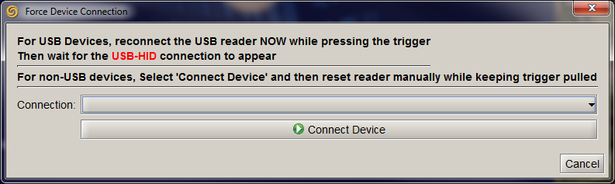
  - After connecting to the scanner, Aladdin will display the configuration screen. Click on Interface Selection on the left side of the window. On the right side of the window will be a drop down box to select the interface.
    - Scroll down and select USB-COM.
    - Click the Write Configuration button
    - Close Aladdin
    - 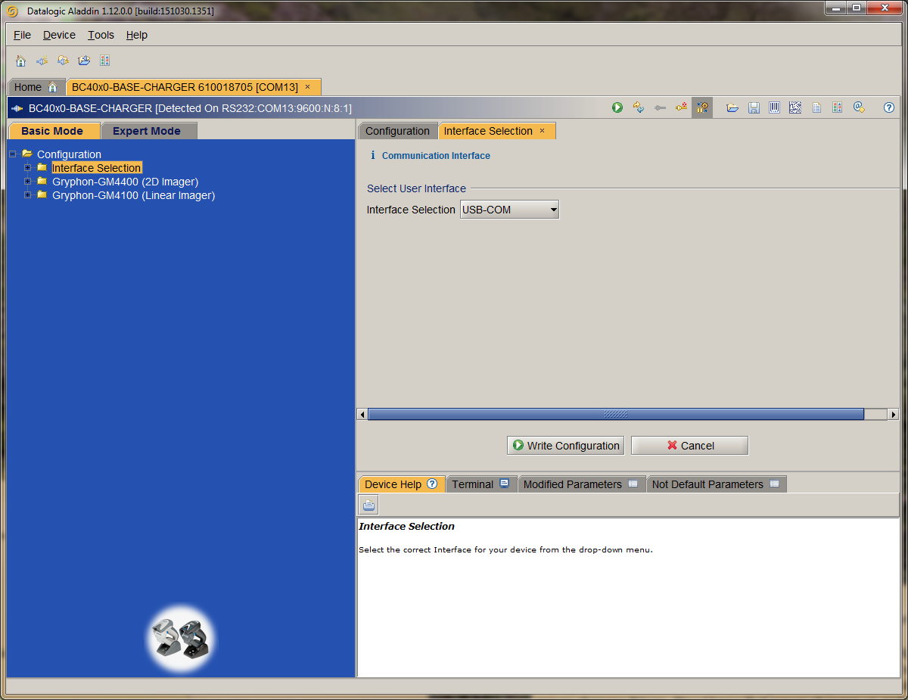

Input Server Setup:
- Install the Input Server software on Windows.
- Under the Configure menu, select Port Settings
  - 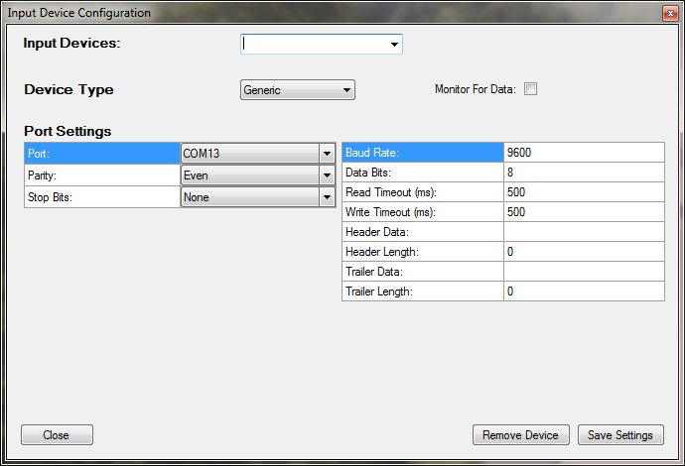
- Fill in the fields with the scanner data. In the Input Devices box, you can provide a name for the scanner. Make sure to check the Monitor for Data check box and fill in the correct port settings. After all entries have been made, click the Save Settings button followed by the Close button.
- The Input Server main window should now show the scanner you configured:
  - 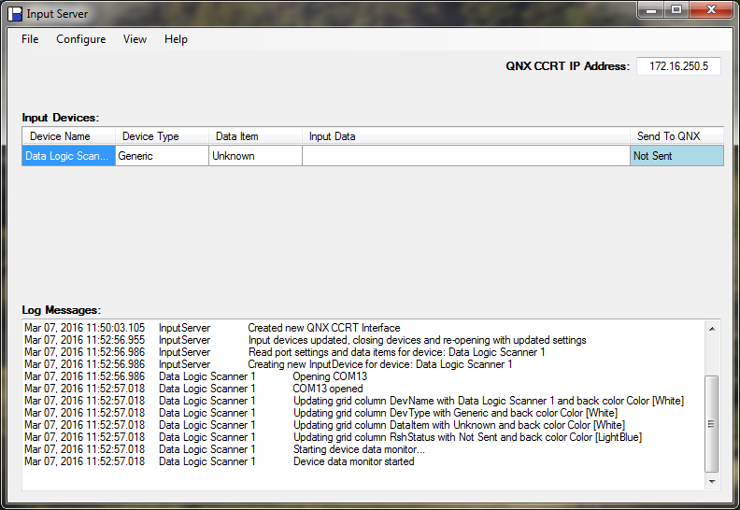
- You may need to update the QNX IP Address. Please note the QNX CCRT IP Address box will turn green after you scan an item.
- Data Items (VIN, NextVIN, etc) can be configured by selecting Data Items from the Configure menu. If scanned data matches the criteria for a data item, the data item will be written to the QNX CCRT system. Please note the Data Item name should match up to a CCRT tag name. A few examples are preconfigured and can be removed or updated as needed.

